ROYAL OAK INTERNATIONAL SCHOOL
SR. SEC. C.B.S.E. AFFILIATED
HOLIDAY HOMEWORK (SESSION 2018-19)

Subject: Math Class I Sec: __
Name: ________ Roll no: ___

Q1. Match the numbers with their number names.
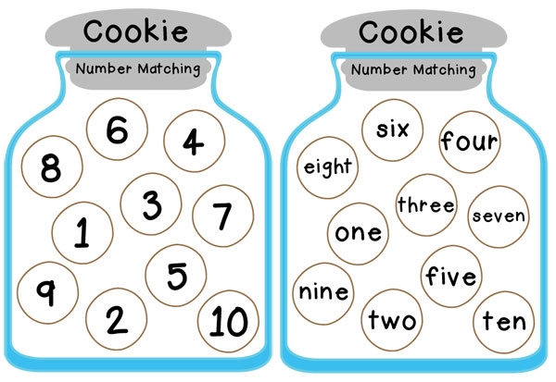
Q2. Complete the picture with matching the dots. 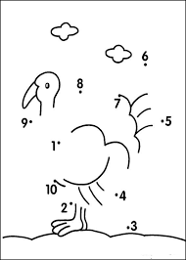

Q3. Fill in the place holder.
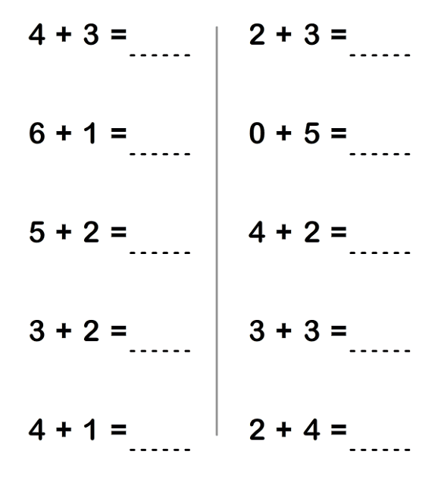
Q4. Solve the followings.
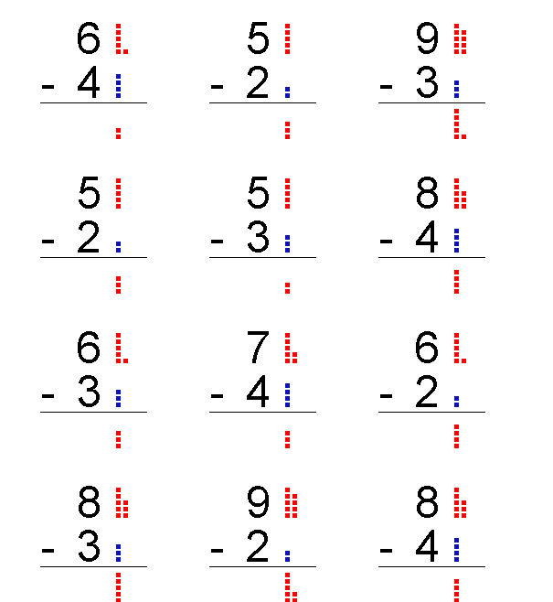

Q5. Problem Sums.
- Jill had 9 pencils. She gave away 4 pencils to Sam. How many pencil does she have now?

- Tina had 8 donuts. Out of which she ate 5. How many donuts
are left now?

- Sam has 5 pens and Dan has 2 pens. How many pens
are there in all?

- We see 2 Bugs and then we see 4 more bugs. How many bugs did we see in all?

Q6. Fill in the placeholder.
BEFORE BETWEEN AFTER
____ 8 3 ____5 9 ____
____ 7 5 ____ 7 7 ____
____ 5 1 ____ 3 3 ____
____ 4 8 ____ 10 1 ____

Q7. Color the one which is different in each row.

Q8. Add them in columns.
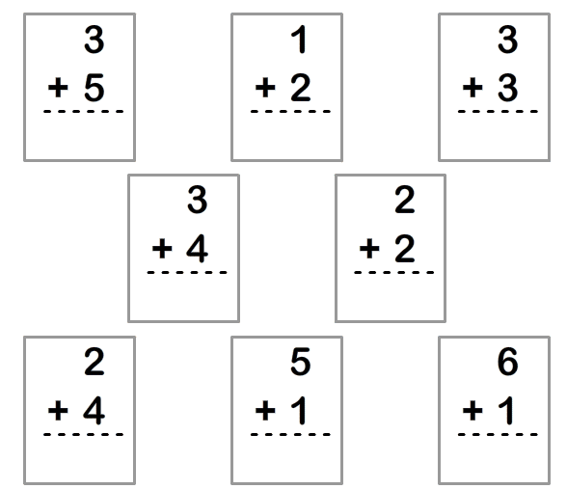
Q9. Put the correct symbol < , > or =.
- 6 5 d) 4 4
- 9 2 e) 5 7
- 3 2 f) 1 7
Q10. Fill in the missing numbers:
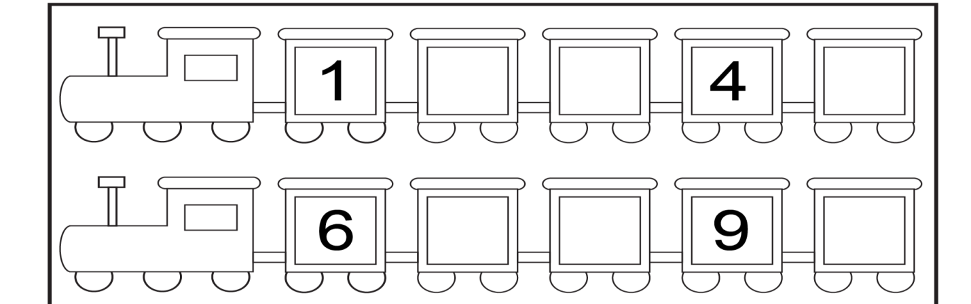
Q11. Fill in the blanks.
- ____ is before 3. d) 3 is after ____.
- _____ is after 10. e) 9 is before ____
- ____ is between 7 and 10. f) 4 is between ____ and 6.

